Assignment for Module 10 Solution
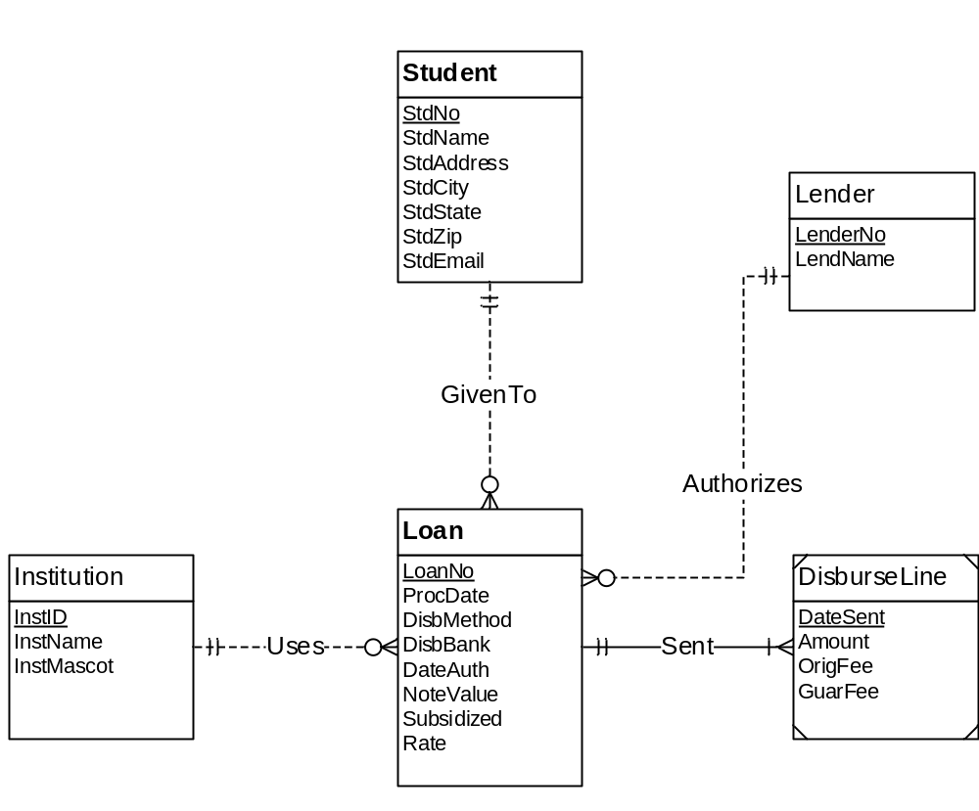
Figure 1: ERD for Problems 1 to 4
Entity Rule:
CREATE TABLE Student(StdNo,StdName,StdAddress,StdCity,StdState,StdZip,StdEmail)
CONSTRAITS PRIMARY KEY (StdNo);

CREATE TABLE Institution(InstId,InstName,InstMascot)
CONSTRAITS PRIMARY KEY (InstId);

CREATE TABLE Lender(LendNo,LendName)
CONSTRAITS PRIMARY KEY (LendNo);

1-M rule:

Create Loan(LoanNo,InstId,StdNo,LenderNo, PrcDate, DisbMethos,DisbBank,DateAuth, NoteValue,Subsidized,Rate),
PRIMAR KEY(LoanNo),
FOREIGN KEY (StdNo) references Student,
FOREIGN KEY (LenderNo) references Lendor,
FOREIGN KEY (InstId) references Institution
StdNo NOT NULL, LenderNo NOT NULL, InstId NotNull;

Identify relations:

CREATE DisburseLine(LoanNo, DateSent, Amount, OrigFee, GuarFee)
Primary key (LoanNo,DateSent),
foreign key LoanNo refences Loan,
LoanNo not null;

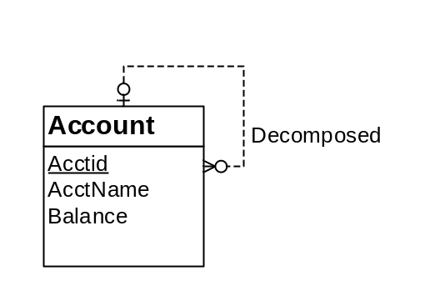
Figure 2: ERD for Conversion Problem 5
Create Account(AcctId, supacctno, AcctName, Balance)
primary key (AcctNo),
foreign key supacctno references Account;

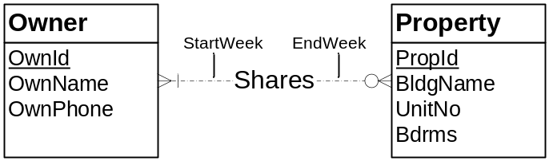
Create table Owner(OwnId,OwnName,OwnPhone)
primary key (OwnId);
Create table Property(PropId,BldgName,UnitNo,Bdrms)
primary key (PropId);
Create Table Share(OwnId,PropId)
Primarykey(OwnId,PropId)
Foreign key (OwnId) references Owner
Foreign key (PropId) references Property

